Classification Programming Assignment

Artem Abalmasov, Lucas Johnson, Xiaohu Wang, Andrew Wellman Taylor

- Executive Summary
This project develops and evaluates neural network classifiers as decision-support tools to determine whether targeted advertising campaigns are financially worthwhile for specific households. The classification task involves mapping two socioeconomic indicators—the Local Affluence Code (LAC) and Size of Wallet (SOW)—to a binary output called Targeted Advertising Campaign Assignment (TACA), where 1 indicates a favorable return on investment, and 0 indicates that advertising is not cost-effective.

Four distinct network architectures were tested and compared: a single-layer perceptron classifier, a two-perceptron two-layer model tested with both random and initialized weights, and a four-perceptron two-layer feed-forward backpropagation network. Training methodologies varied by architecture; the baseline models utilized an online learning approach repeated over 30 sequential cycles, while the advanced multi-layer variants were trained for 1000 iterations using a degrading learning curve and Simulated Annealing optimizations. Sigmoid outputs were converted to discrete classifications via threshold optimization, allowing for robust Receiver Operating Characteristic (ROC) analysis across separate training and testing data partitions.

The comparative analysis aimed to highlight the limitations of linear classification models against the capabilities of nonlinear decision systems in socioeconomic pattern recognition, specifically examining the impact of smart weight distribution versus random initialization. While the single-layer perceptron offers a computationally efficient baseline, its capacity is strictly limited to linear decision boundaries, rendering it insufficient for capturing the nuanced, non-linear interactions between wealth indicators and advertising profitability. Conversely, the feed-forward backpropagation (FFBP) networks incorporate hidden-layer neurons that enable the learning of complex feature interactions, theoretically offering improved classification performance and stability.

Performance analysis revealed disparities between theoretical capacity and actual learning outcomes. The linear perceptron achieved a training F1 score of 0.89 but failed to generalize, dropping to a Test F1 score of 0.50, confirming that the data possesses a non-linear "Exclusive-OR" (XOR) topology that linear classifiers cannot separate. Contrary to the assumption that increased complexity guarantees better results, both the randomly initialized two-perceptron and four-perceptron models failed to outperform this linear baseline, yielding the same Test F1 score of 0.50. This failure is attributed to the small dataset size violating the 10:1 samples-to-parameters rule, causing the models to become trapped in local minima despite their theoretical capacity. Consequently, the only architecture to achieve high predictive accuracy was the two-perceptron network initialized with human-guided weights, which achieved a perfect Training F1 score of 1.0 and a Test F1 score of 0.80.

These findings demonstrate the importance of domain knowledge and problem analysis, as evidenced by the fact that the non-random model converged to an optimal solution while the randomly initialized four-perceptron model did not. The results affirm that even modest multi-layer networks can significantly improve accuracy in problems with overlapping distributions. The study confirms the practical value of neural learning approaches as adaptive decision-support tools capable of optimizing advertising strategies by pinpointing households most likely to deliver positive returns.

- Introduction
  - Problem Description
The objective of this project is to develop neural network classifiers that can predict whether targeted advertising to a household is likely to generate a positive financial return. The classification task uses two continuous socioeconomic input variables: the Local Affluence Code, which estimates neighborhood wealth and housing quality, and the Size of Wallet, which assesses disposable household income and spending capacity. Both variables range in value from 0 to 3. The network outputs a binary decision variable called Targeted Advertising Campaign Assignment. A TACA value of 1 indicates that targeted advertising is expected to be profitable for that household, while a TACA of 0 suggests the investment is unlikely to provide sufficient returns.

Historical response data from advertising efforts for twenty households served as training data for the networks. The small size of this data set reflects real-world constraints in marketing analytics, where gathering accurate demographic and purchase information can be cost-prohibitive. Consequently, the learning challenge is fundamental: the dataset is limited, feature dimensions are low, and the boundary separating profitable from unprofitable households might be nonlinear or overlapping. The aim is not to build a general-purpose commercial system, but to assess whether neural networks can discover meaningful classification patterns in such constrained scenarios.

  - Network Design
Two neural network architectures were selected for comparison. The first is a single-layer perceptron with two weighted inputs (LAC and SOW), a bias, and a sigmoid activation function at the output, as shown in Figure 2. This model creates a linear decision boundary in the two-dimensional input space. While this approach is computationally simple and straightforward to train, it can only correctly classify linearly separable data. Datasets requiring curved or multi-segment decision boundaries cannot be accurately modeled with this structure. As shown in Figure 1, we can see that this dataset is not separable by a single perceptron. Hence, in this project we utilize the single-layer perceptron as a baseline classifier for comparison.

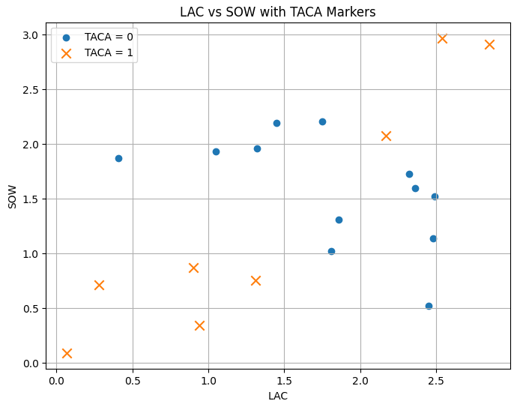
Figure 1: Data Distribution

The second architecture, shown in Figure 3, is a feed-forward backpropagation network with an input layer of two nodes, a hidden layer with sigmoid neurons, and an output layer with a single sigmoid neuron. The hidden layer enables the network to perform nonlinear transformations of the input features, thereby approximating complex decision surfaces. Weights were updated using gradient descent backpropagation based on the squared error between the predicted and target outputs. This learning process propagates errors backward through the network to refine the parameters in both the hidden and output layers, enabling the network to discover internal feature representations that a linear model cannot capture.
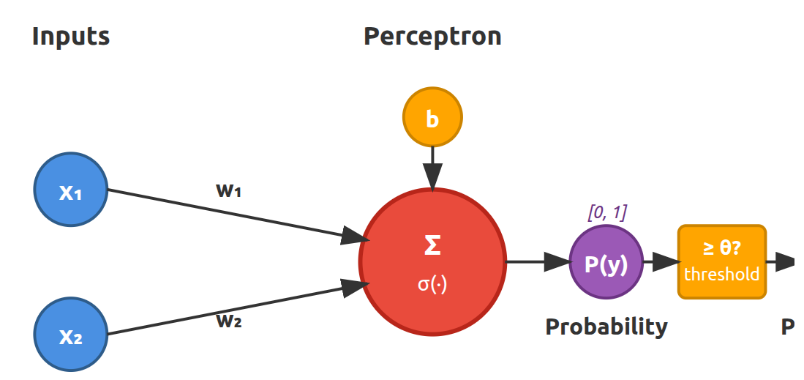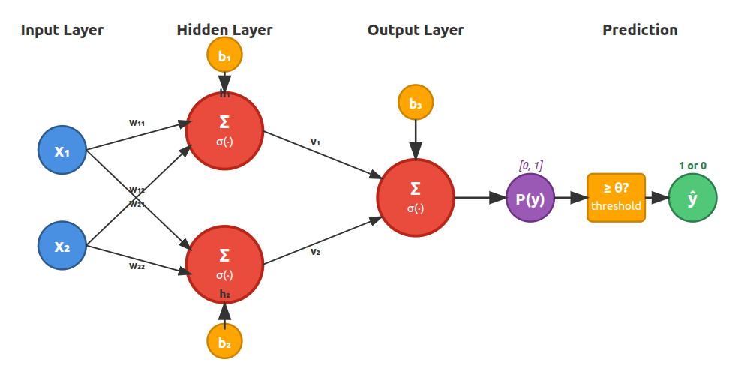

Figure 2 and 3. Single perceptron model, and two-layer with two-perceptron model, respectively.

Training for both networks uses the same online learning method specified by the assignment. Only the data from households with odd indices were used for training, and the process was repeated over 30 cycles of sequential sample presentation to minimize the overall error function. After training, raw sigmoid outputs were converted into discrete TACA class decisions through systematic threshold adjustments. Tuning these thresholds enabled evaluation of the networks’ classification behavior across a range of operating points, rather than a fixed cutoff. This process produced data for ROC analysis, which measured sensitivity (true-positive rate) and specificity (true-negative rate). Final performance was evaluated on the even-indexed dataset using the optimized thresholds, ensuring evaluation of unseen data.

Together, these two networks provide a controlled way to examine the representational power needed for the targeted advertising classification task. The linear perceptron tests the adequacy of simple decision boundaries, while the FFBP network demonstrates the advantages of nonlinear modeling. Comparing these models shows how architectural complexity affects predictive performance and supports the broader conclusion that real-world socio-economic classification tasks typically require multidimensional, nonlinear solutions rather than simple linear separators.

Computational Performance
We organized our model selections into two parts: the first includes the models mandated by the programming assignment, and the second more advanced variants developed for comparative analysis. All architectures employ a perceptron-based computational unit with an associated bias term and sigmoid activation function. After computing the sigmoid output, we apply a threshold to obtain the final TACA prediction of either 1 or 0. For each architecture, we compute the ROC curve by calculating the True Positive Rate and False Positive Rate for each threshold value from 1 to 0 with a step size of 0.01.

Classical Models

Single Perceptron Model
This model consists of a single perceptron with a sigmoid activation at the output. After 30 training iterations, the resulting ROC curves for the training and testing sets are presented in Figures 4 and 5, respectively. These curves corroborate the initial visual assessment from Figure 1, indicating that a single linear decision boundary was insufficient to separate the classes in this dataset.
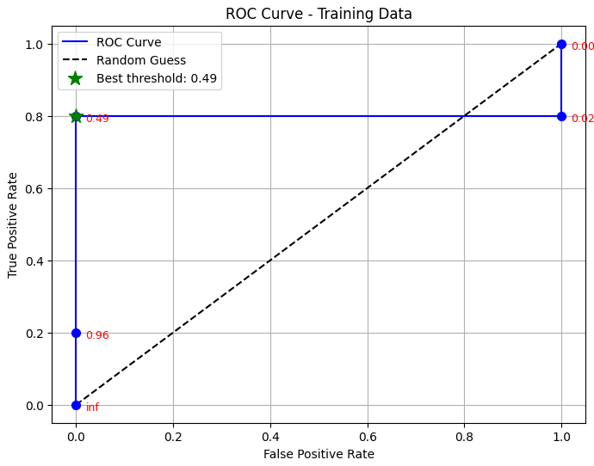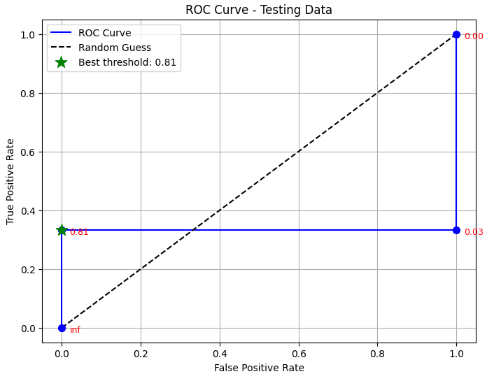
Figure 4 and 5. ROC curve for a single perceptron on training and testing data, respectively.

Figure 6 visualizes the decision boundaries obtained for both the single- and two-perceptron models under random initialization. For the single perceptron, the learned boundary aligns with intuitive expectations but does not fully capture the underlying class structure. As reported in Table 1 and Code 1, the model achieved an F1 score of 0.88 on the training set, with an optimal threshold of approximately 0.495. On the test set, however, the F1 score decreased to 0.50.

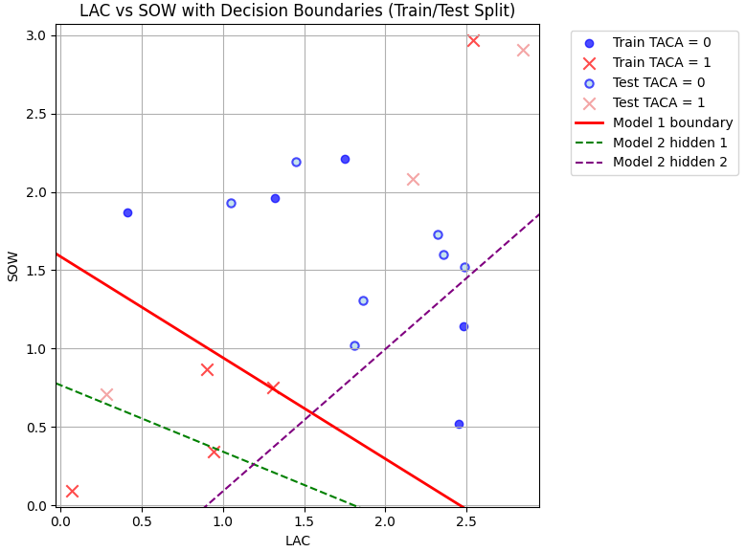
Figure 6. Decision boundaries for one perceptron and a random two-perceptron model.

Although this threshold was not optimal for the test data, selecting an optimal threshold is generally challenging in practical settings. For the purpose of this baseline model, the threshold identified from the training performance was applied to the test evaluation.

Two Perceptron Model
The two-perceptron model has been designed according to the specifications of the programming assignment. We maintain 30 training iterations and initialize weights and biases with random values. Despite its increased representational capacity, the model exhibited performance metrics nearly identical to those of the single perceptron, differing only in a slightly more favorable threshold. On the test data, the ROC curve appears slightly improved, as shown in Figure 7. As we observe in Figure 8, random initialization of the two-perceptron network results in poor decision boundaries that fail to effectively separate the classes despite the increased model capacity.

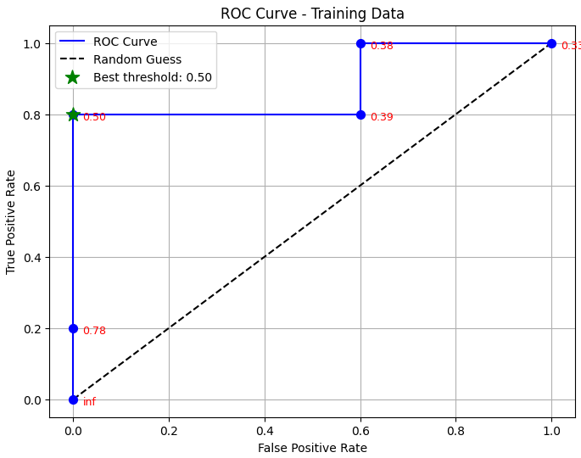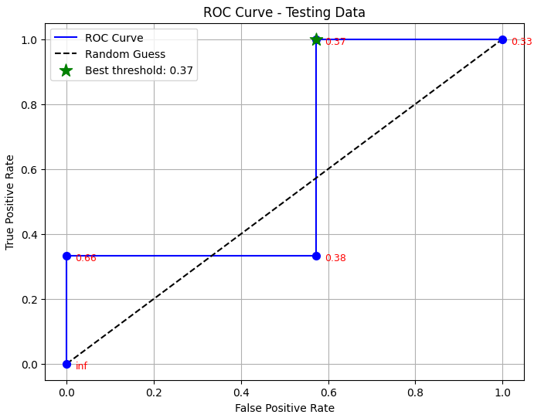
Figure 7 and 8. ROC curve for a two-perceptron model on training and testing data, respectively.

Advanced Models
For advanced models, we implemented optimization strategies to improve both the architectural approach and training techniques to produce better results. We increase iterations to 1000, with an initial learning rate of 1.0 and a degradation rate of 0.99. This means the learning rate eta is multiplied by the degradation rate with every iteration to stabilize convergence. Additionally, we implement a simulated annealing algorithm. This technique is particularly applicable because random initialization appears to trap the network in numerous local minima, and we seek a mechanism to find the global minimum.

Two-Neuron Model with Non-Random Weights
Beyond the above modifications, we can visually identify approximate boundaries to separate the classes from Figure 1. By setting initial weights based on these observed boundaries, we guide the optimization process toward a superior solution. With these strategically chosen starting points and the optimization approach described above, the F1 score on training data reaches 1.0 and test data achieves 0.8 using the same threshold. The corresponding ROC curves are presented in Figures 9 and 10.

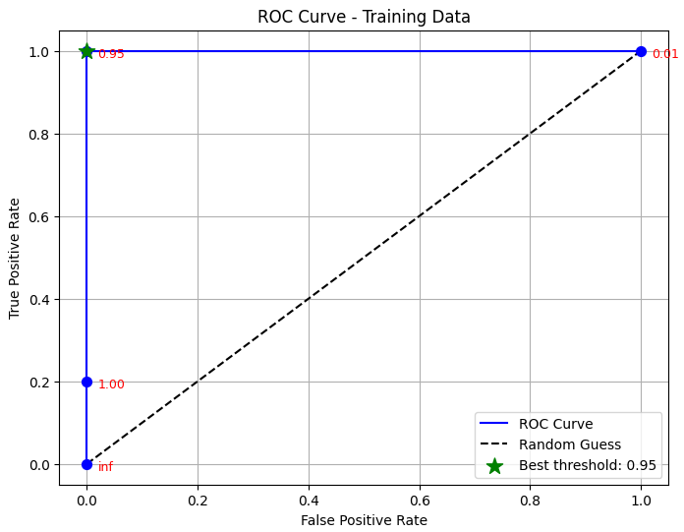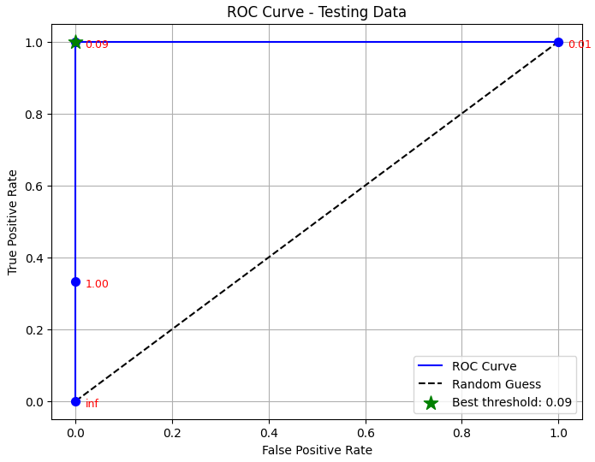
Figure 9 and 10. ROC of non-randomly seeded two-layer network on training and test data, respectively.

The F1 score for test data is not 1.0 because of one point with a TACA score of 1 that is positioned very close to a cluster of TACA=0 points, as visible in Image 1. With the proper threshold, this model achieves perfect classification on the training dataset. The decision boundaries for this optimized model are shown in Figure 11.

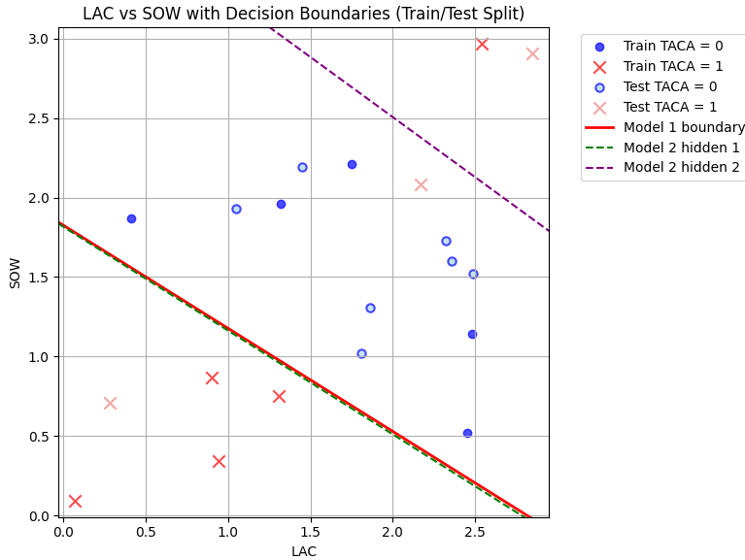
Figure 11. Boundaries for NN with a good starting point

Four-Perceptron Model with Random Parameter Initialization
As a final experiment, we test the same two-level architecture but with four perceptrons in the hidden layer. As we can see from Figures 12 and 13 and the metrics in Code 5, this increased model capacity does not outperform the randomly initialized two-perceptron model. The F1 scores remain at 0.88 for training and 0.5 for test data, demonstrating that simply adding more perceptrons without strategic initialization or sufficient optimization does not improve performance.

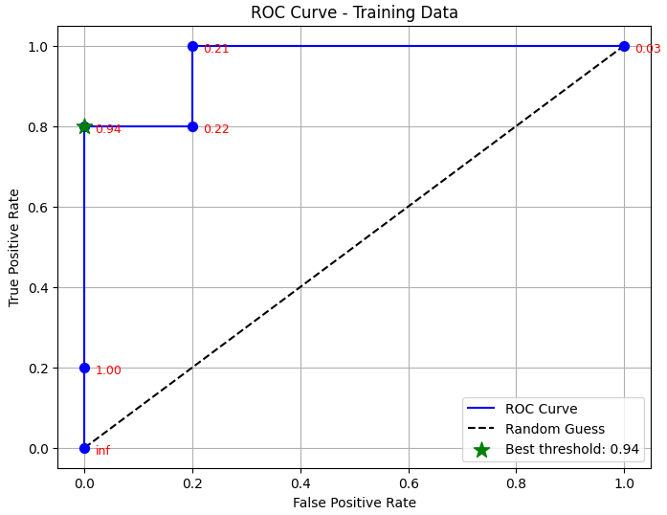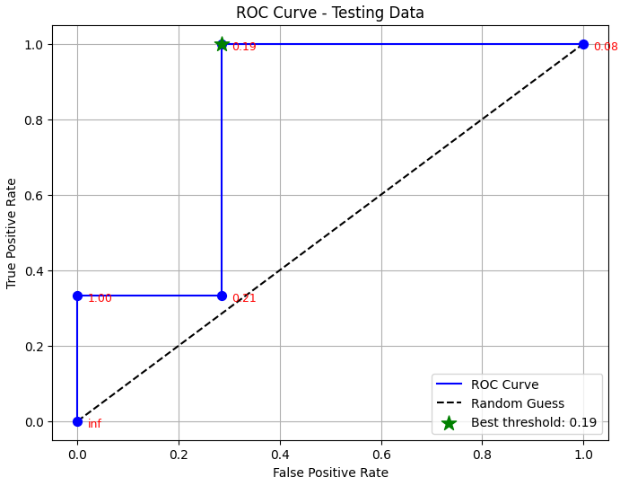
Figure 12 and 13. ROC curve for four-perceptron training data and test data, respectively.

Analysis

Performance Comparison Across Architectures
Our experimental results revealed substantial differences in performance across architectures and initialization strategies. The single-perceptron model served as a baseline and achieved an F1 score of 0.8889 on the training set at the threshold selected via Youden’s J statistic (0.4965). At this operating point, the model attained perfect specificity (1.0000) with sensitivity of 0.8000, yielding a confusion matrix of TN = 5, FP = 0, FN = 1, and TP = 4. This profile indicates that the perceptron made no false-positive predictions on the training data but did miss one positive case.

When the same threshold was applied to the test set, performance degraded notably: the F1 score dropped to 0.5000, with sensitivity decreasing to 0.3333 while specificity remained at 1.0000 (TN = 7, FP = 0, FN = 2, TP = 1). In other words, the model continued to avoid false positives but failed to detect most positive cases in the test data. This generalization gap was consistent with the visual inspection of the dataset in Image 1, which showed that the classes are not separable by a single linear boundary.

The randomly initialized two-perceptron model exhibited ROC behavior that closely mirrored the single-perceptron baseline. On the training set, the most favorable ROC point appeared at a threshold of approximately 0.52, at which the model achieved a true positive rate of 0.80 and a false positive rate of 0.00, exactly matching the optimal operating point reached by the single perceptron (TPR = 0.80, FPR = 0.00). This indicates that, despite its additional computational units, the two-perceptron model is statistically indistinguishable from baseline. The test-set ROC also exhibited the same pattern. As with the single-perceptron model, such ROC behavior suggests a conservative decision profile in which the classifier maintains perfect specificity at the cost of reduced sensitivity. Thus, the additional hidden neuron did not translate into improved statistical separability.

The overall comparison demonstrates a consistent pattern: when initialized naively, our classic models of different capacity produced nearly identical ROC characteristics, sensitivity/specificity tradeoffs, and threshold-dependent behaviors.

By contrast, the optimized two-perceptron model initialized using approximate decision boundaries inferred from the data visualization produced a markedly different statistical profile. This model achieved a perfect classification of the training data, eliminating the false negative observed in the baseline and reaching TPR = 1.00 and FPR = 0.00. On the test set, the model reported an F1 score of 0.80, an improvement over the 0.50 achieved by both the single perceptron and the random two-perceptron model.

Highlighting Initialization
Our experiments revealed that weight initialization played a central role in how the models ultimately performed. A close inspection of the data distribution in Figure 1 allowed us to sketch out plausible linear boundaries between the two classes, and these observations provided a useful starting point for selecting initial weights in the two-perceptron network.

These findings highlight a broader caveat about training neural networks: familiarity with the underlying data can meaningfully influence optimization. Although random initialization is theoretically sufficient, in practice, it often leads the model into local minima that standard gradient methods struggle to escape. In this project, utilizing visual inspection of the dataset’s distribution proved more effective than relying solely on algorithmic procedures, suggesting that informed initialization strategies can be an essential complement to the training process.

Future Directions
Several promising directions could extend and improve upon this work. First, a larger dataset would enable more reliable performance assessment and potentially reveal whether additional model complexity becomes beneficial at scale. With more samples, we could implement k-fold cross-validation to obtain robust performance estimates and better understand model variance.

Exploring alternative optimization algorithms such as Adam, RMSprop, or stochastic gradient descent with momentum could also potentially achieve similar or better results than simulated annealing while requiring less manual tuning of hyperparameters. These modern optimizers incorporate adaptive learning rates and momentum terms that can help escape local minima without the computational overhead of temperature schedules.

Conclusion
This project evaluated the viability of neural network classifiers in predicting advertising profitability (TACA) based on limited socioeconomic indicators (LAC and SOW). Through a comparative analysis of linear perceptrons, multi-layer feed-forward networks, and varying initialization strategies, the study yields three critical conclusions regarding model complexity, the optimization landscape, and the role of human oversight in machine learning.

First, the results definitively establish the limitations of linear modeling for this specific socioeconomic domain. The single-layer perceptron achieved a hard performance ceiling (Training F1: 0.89, Test F1: 0.50), confirming that the boundary between profitable and unprofitable households is not linearly separable. The data distribution possesses an XOR topology, where high-affluence/low-wallet and low-affluence/high-wallet households interact non-linearly. This necessitates a classifier capable of bending the decision hypersurface, a theoretical property of multi-layer networks.

Second, and perhaps most significantly, this study deconstructs the assumption that increased architectural complexity automatically yields superior performance. Both the randomly initialized two-perceptron and four-perceptron networks failed to outperform the linear baseline. Despite possessing the theoretical capacity to model the required non-linearities, these networks were unable to converge on a solution via standard backpropagation and simulated annealing alone.

This failure highlights a fundamental reality in neural computing: capacity is a necessary but insufficient condition for learning. This behavior can be attributed to the “10:1 Rule of Thumb” in statistical learning, which suggests one requires approximately ten training examples for every learnable parameter to guarantee robust convergence. With only ten training samples and a network approaching nine parameters (weights + biases), the model effectively operates in an ill-posed regime. The error surface for this problem – likely riddled with saddle points rather than simple local minima due to the sparsity of the data – rendered standard gradient descent ineffective.

Third, the success of the non-randomly initialized network (Training F1: 1.0, Test F1: 0.80) demonstrates the efficacy of “hybrid intelligence.” By visually inspecting the dataset and encoding a coarse approximation of the decision boundaries into the initial weights, we bypassed the initial pitfalls of the optimization landscape. This acts as a form of transfer learning, where human geometric intuition breaks the symmetry of the weight space, allowing the algorithm to fine-tune a solution rather than search for one blindly.

However, a rigorous analysis of the “winning” model suggests caution. The gap between perfect training performance (F1: 1.0) and the test performance (F1: 0.80) indicates the onset of overfitting. In the context of the Vapnik–Chervonenkis (VC) dimension, the model's capacity slightly exceeds the information content of the small training set, leading to it “memorizing” certain artifacts of the training data. This is a measure of the capacity – or complexity – of a statistical classification algorithm. Formally, it is defined as the cardinality of the largest set of points that the algorithm can “shatter” the model's capacity slightly exceeds the information content of the small training set, leading it to memorize certain artifacts of the training data. To guarantee statistical confidence that your model is learning rather than memorizing, you generally need the number of training samples ($N$) to exceed the VC dimension ($d$) by a significant margin. The Heuristic is: $N≥10×d$, as was noted.

While neural networks offer a powerful decision-support tool for targeted advertising, they are not magic black boxes. For datasets of this limited size, success depends less on the depth of the network and more on the initialization of the search. The optimal strategy identified is a modest non-linear architecture guided by human insight, ensuring that the model captures the nuance of consumer behavior without succumbing to the instability of the learning process.

Appendix
Figure 1. Dataset visualized

Figure 2. Single perceptron with a sigmoid activation and a threshold

Figure 3. Two-layer with two-perceptron model.

Figure 4. ROC curve for a single perceptron on training data.

Figure 5. ROC curve for a single perceptron on testing data.
Figure 6. Decision boundaries for one perceptron and a random two-perceptron model.

 | Predicted
Actual | 0 | 1
0 | 5 | 0
1 | 1 | 4
Table 1. Confusion Matrix for a single perceptron
Sensitivity (Recall): 0.8000
Specificity: 1.0000
Precision: 1.0000
F1 Score: 0.8889
Accuracy: 0.9000
Code 1. Metrics for a single perceptron on rain data.

 | Predicted
Actual | 0 | 1
0 | 7 | 0
1 | 2 | 1
Table 2. Confusion Matrix for a single perceptron on test data
Sensitivity (Recall): 0.3333
Specificity: 1.0000
Precision: 1.0000
F1 Score: 0.5000
Accuracy: 0.8000
Code 2. Metrics for a single perceptron on test data.

Figure 7. ROC curve for a two-perceptron model on training data.

Figure 8. ROC curve for a two-perceptron model on test data

Train metrics
Confusion Matrix (threshold = 0.49537257574269683):

 | Predicted
Actual | 0 | 1
0 | 5 | 0
1 | 1 | 4

Sensitivity (Recall): 0.8000
Specificity: 1.0000
Precision: 1.0000
F1 Score: 0.8889
Accuracy: 0.9000

Test metrics
Confusion Matrix (threshold = 0.49537257574269683):

 | Predicted
Actual | 0 | 1
0 | 7 | 0
1 | 2 | 1

Sensitivity (Recall): 0.3333
Specificity: 1.0000
Precision: 1.0000
F1 Score: 0.5000
Accuracy: 0.8000
Code 3. Two-perceptron random initialization metric

class Perceptron:
def __init__(self, n_inputs, eta=0.1, weights=None, bias=None):
self.eta = eta
self.weights = np.array(weights if weights is not None else np.random.randn(n_inputs))
self.bias = bias if bias is not None else np.random.randn()

# Fields initialized
self.delta_weights = np.zeros_like(self.weights)
self.delta_bias = 0.0
self.activity = 0.0
self.activation = 0.0
self.delta = 0.0

def calc_activity(self, x):
self.activity = np.dot(self.weights, x) + self.bias
return self.activity

def calc_activation(self):
self.activation = 1.0 / (1.0 + np.exp(-self.activity))
return self.activation

def set_delta(self, target):
f_prime = self.activation * (1 - self.activation)
self.delta = (target - self.activation) * f_prime
return self.delta

def set_delta_weights(self, x):
self.delta_weights = self.eta * self.delta * x
self.delta_bias = self.eta * self.delta
return self.delta_weights, self.delta_bias

def update_weights(self):
self.weights += self.delta_weights
self.bias += self.delta_bias

def predict(self, x):
self.calc_activity(x)
return self.calc_activation()

def fit(self, x, target):
self.predict(x)
self.set_delta(target)
self.set_delta_weights(x)
self.update_weights()

class PerceptronLayer:
def __init__(self, n_perceptrons, n_inputs, eta=0.1, weights=None, bias=None, is_output_layer=True):
self.layer_length = n_perceptrons
self.OutputLayerFlag = is_output_layer
self.n_inputs = n_inputs

# Initialize layer of perceptrons
self.layer = []
if weights is not None:
self.layer_weight = weights
for i in range(n_perceptrons):
perceptron = Perceptron(n_inputs, eta=eta, weights=weights[i], bias=bias[i] if bias is not None else 0.0)
self.layer.append(perceptron)
else:
self.layer_weight = []
for i in range(n_perceptrons):
perceptron = Perceptron(n_inputs, eta=eta,bias=bias[i] if bias is not None else 0.0)
self.layer.append(perceptron)
self.layer_weight.append(perceptron.weights.copy())

# Initialize output and error vectors
self.output_vector = np.zeros(n_perceptrons)
self.littleE_vector = np.zeros(n_perceptrons)

def get_layer_length(self):
return self.layer_length

def get_layer_output_vector(self, input_vector):
for i, perceptron in enumerate(self.layer):
self.output_vector[i] = perceptron.predict(input_vector)
return self.output_vector

def get_error_vector(self, desired_output_vector):
if self.OutputLayerFlag:
self.littleE_vector = desired_output_vector - self.output_vector
return self.littleE_vector

def set_output_layer_delta_values(self, desired_output_vector):
for i, perceptron in enumerate(self.layer):
perceptron.set_delta(desired_output_vector[i])

def set_hidden_layer_delta_values(self, upper_layer):
for i, perceptron in enumerate(self.layer):
# Calculate weighted sum of deltas from upper layer
weighted_delta_sum = 0.0
for j, upper_perceptron in enumerate(upper_layer.layer):
weighted_delta_sum += upper_perceptron.delta * upper_perceptron.weights[i]

# Set delta using derivative of activation function
f_prime = perceptron.activation * (1 - perceptron.activation)
perceptron.delta = weighted_delta_sum * f_prime

def calc_layer_delta_weights(self, input_vector):
for perceptron in self.layer:
perceptron.set_delta_weights(input_vector)

def update_layer_weights(self):
for perceptron in self.layer:
perceptron.update_weights()

Code 4. Perceptron and Perceptron Layer code used.

#With SA

degradation_coeff = 0.99
initial_temp = 10.0
min_temp = 0.001
debug = 100
max_iterations = 1000

def fit(hidden_layer, output_layer):
temp = initial_temp

# Store best weights found
best_error = float('inf')
best_hidden_weights = None
best_hidden_biases = None
best_output_weights = None
best_output_biases = None

def save_weights():
"""Save current weights"""
hidden_w = [p.weights.copy() for p in hidden_layer.layer]
hidden_b = [p.bias for p in hidden_layer.layer]
output_w = [p.weights.copy() for p in output_layer.layer]
output_b = [p.bias for p in output_layer.layer]
return hidden_w, hidden_b, output_w, output_b

def restore_weights(hidden_w, hidden_b, output_w, output_b):
"""Restore weights from saved state"""
for i, p in enumerate(hidden_layer.layer):
p.weights = hidden_w[i].copy()
p.bias = hidden_b[i]
for i, p in enumerate(output_layer.layer):
p.weights = output_w[i].copy()
p.bias = output_b[i]

def add_perturbation(scale=0.1):
"""Add random perturbation to weights"""
for p in hidden_layer.layer:
p.weights += np.random.randn(*p.weights.shape) * scale * temp
p.bias += np.random.randn() * scale * temp
for p in output_layer.layer:
p.weights += np.random.randn(*p.weights.shape) * scale * temp
p.bias += np.random.randn() * scale * temp

prev_error = float('inf')

for i in range(max_iterations):
# Save current state before update
current_weights = save_weights()

error = 0.0
for _, row in train_df.iterrows():
x = np.array([row['LAC'], row['SOW']])
y = np.array([row['TACA']])

# 1. Forward pass (both layers)
hidden_out = hidden_layer.get_layer_output_vector(x)
output_result = output_layer.get_layer_output_vector(hidden_out) # Changed variable name

# 2. Backward pass - calculate deltas (output first, then hidden)
output_layer.set_output_layer_delta_values(y) # Use output_layer, not output
hidden_layer.set_hidden_layer_delta_values(output_layer) # Use output_layer, not output

# 3. Calculate delta weights (don't update yet!)
output_layer.calc_layer_delta_weights(hidden_out)
hidden_layer.calc_layer_delta_weights(x)

# 4. NOW update all weights
output_layer.update_layer_weights()
hidden_layer.update_layer_weights()

error += (y - output_result) ** 2 # Use output_result

error = error[0] / len(train_df)

# Simulated annealing decision
if error < prev_error:
# Better solution - always accept
accept = True
else:
# Worse solution - accept with probability based on temperature
delta_error = error - prev_error
acceptance_prob = np.exp(-delta_error / temp)
accept = np.random.random() < acceptance_prob

if accept:
# Keep new weights
prev_error = error

# Track best solution found
if error < best_error:
best_error = error
best_hidden_weights, best_hidden_biases, best_output_weights, best_output_biases = save_weights()
else:
# Reject - restore previous weights
restore_weights(*current_weights)

# Optionally add random perturbation to escape local minima
if temp > min_temp and i % 50 == 0:
add_perturbation(scale=0.05)

# Cool down temperature
temp = max(min_temp, temp * degradation_coeff)

if debug and i % debug == 0:
print(f"Iteration {i}: Error = {error:.6f}, Temp = {temp:.4f}, Best = {best_error:.6f}")

# Restore best weights at the end
print(f"\nRestoring best weights with error: {best_error:.6f}")
restore_weights(best_hidden_weights, best_hidden_biases, best_output_weights, best_output_biases)

fit(model2_hidden_layer, model2_output_layer)
Code 4. Back propagation code for network with one hidden layer

Figure 9. ROC of non-randomly seeded two-layer network on train data

Figure 10. ROC of non-randomly seeded two-layer network on test data

Train metrics
Confusion Matrix (threshold = 0.9454025030533182):

 | Predicted
Actual | 0 | 1
0 | 5 | 0
1 | 0 | 5

Sensitivity (Recall): 1.0000
Specificity: 1.0000
Precision: 1.0000
F1 Score: 1.0000
Accuracy: 1.0000

Test metrics
Confusion Matrix (threshold = 0.9454025030533182):

Predicted
0 1

 | Predicted
Actual | 0 | 1
0 | 7 | 0
1 | 1 | 2

Sensitivity (Recall): 0.6667
Specificity: 1.0000
Precision: 1.0000
F1 Score: 0.8000
Accuracy: 0.9000
Code 4. Metrics for two-perceptron model with train-optimized threshold

Figure 11. Boundaries for NN with a good starting point

Figure 12. ROC curve for four-perceptron on training data

Figure 13. ROC curve for four-perceptron on test data

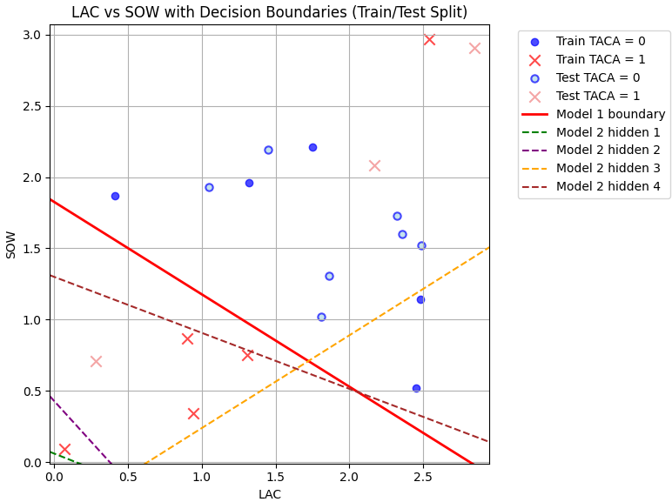
Figure 14. ROC curve for four-perceptron on test data

Train metrics
Confusion Matrix (threshold = 0.941468995812662):

 | Predicted
Actual | 0 | 1
0 | 5 | 0
1 | 1 | 4

Sensitivity (Recall): 0.8000
Specificity: 1.0000
Precision: 1.0000
F1 Score: 0.8889
Accuracy: 0.9000

Test metrics
Confusion Matrix (threshold = 0.941468995812662):
Predicted
0 1

 | Predicted
Actual | 0 | 1
0 | 7 | 0
1 | 2 | 1

Sensitivity (Recall): 0.3333
Specificity: 1.0000
Precision: 1.0000
F1 Score: 0.5000
Accuracy: 0.8000
Code 5. Metrics for four-perceptron model

